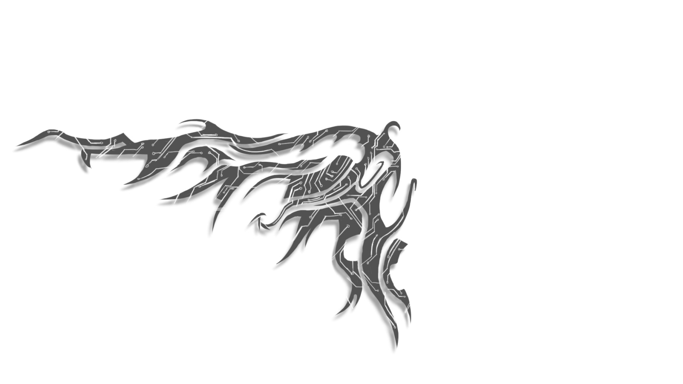
Tyler Anderson
(971)226-7859
tyandersonart.com
tyandersonart@gmail.com
Technical/Environment Artist
______________________________________________________
-Range of art and technical backgrounds.
-Values teamwork and criticism, yet independent and self-motivated.
-Strongly detail-oriented, loves building and exploring virtual worlds.
Experience
Hellborne(Student project, Oct-Dec 2013) – Environment Artist in a team of 30-40 other students. Responsible for creating assets such as ammo crates, destroyed trains, and the Portland Steel Bridge.
Pipeworks Studios (Apr 2014–Present) – General Artist responsible for a variety of tasks like concept art, modeling, texturing, rigging/animating, and scripting a few of my own Maya tools to increase productivity.
Skills
Modeling (hard and organic, stylized and realistic)
Unwrapping and texturing
Painting (Traditional and Digital)
Lighting
3D Animation
Rigging
Programming (shaders, scripting, networking, and AI)
Tools
Maya
Photoshop
Unity
Unreal
After Effects
Final Cut
Visual Studio (C++, OpenGL, Javascript, CSS, and Winsock)
Education
Art Institute of Portland (2010–2013)
BS in Visual Game Programming
Work History
Subway (May 2011-Jan 2014): “Sandwich Artist”
-Reliable (Never called in sick, always on time).
-Sociable toward coworkers and customers.
-Dedication to performing tasks well.

